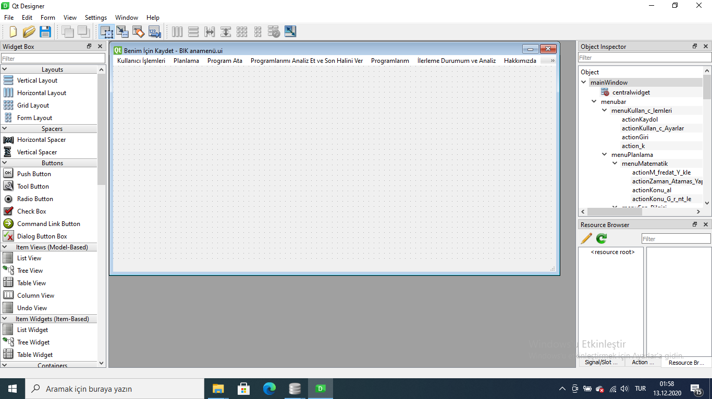

# -*- coding: utf-8 -*-

################################################################################

## Form generated from reading UI file 'BIK anamen�gflGlh.ui'

##

## Created by: Qt User Interface Compiler version 5.14.1

##

## WARNING! All changes made in this file will be lost when recompiling UI file!

################################################################################

from PySide2.QtCore import (QCoreApplication, QMetaObject, QObject, QPoint,

QRect, QSize, QUrl, Qt)

from PySide2.QtGui import (QBrush, QColor, QConicalGradient, QCursor, QFont,

QFontDatabase, QIcon, QLinearGradient, QPalette, QPainter, QPixmap,

QRadialGradient)

from PySide2.QtWidgets import *

class Ui_mainWindow(object):

def setupUi(self, mainWindow):

if mainWindow.objectName():

mainWindow.setObjectName(u"mainWindow")

mainWindow.setWindowModality(Qt.ApplicationModal)

mainWindow.resize(850, 417)

mainWindow.setIconSize(QSize(30, 30))

mainWindow.setDockNestingEnabled(False)

mainWindow.setUnifiedTitleAndToolBarOnMac(False)

self.actionKaydol = QAction(mainWindow)

self.actionKaydol.setObjectName(u"actionKaydol")

self.actionKaydol.setCheckable(False)

self.actionKaydol.setChecked(False)

self.actionKullan_c_Ayarlar = QAction(mainWindow)

self.actionKullan_c_Ayarlar.setObjectName(u"actionKullan_c_Ayarlar")

self.actionGiri = QAction(mainWindow)

self.actionGiri.setObjectName(u"actionGiri")

self.action_k = QAction(mainWindow)

self.action_k.setObjectName(u"action_k")

self.actionM_fredat_Y_kle = QAction(mainWindow)

self.actionM_fredat_Y_kle.setObjectName(u"actionM_fredat_Y_kle")

self.actionZaman_Atamas_Yap = QAction(mainWindow)

self.actionZaman_Atamas_Yap.setObjectName(u"actionZaman_Atamas_Yap")

self.actionKonu_al = QAction(mainWindow)

self.actionKonu_al.setObjectName(u"actionKonu_al")

self.actionKonu_G_r_nt_le = QAction(mainWindow)

self.actionKonu_G_r_nt_le.setObjectName(u"actionKonu_G_r_nt_le")

self.actionM_fredat_Y_kle_2 = QAction(mainWindow)

self.actionM_fredat_Y_kle_2.setObjectName(u"actionM_fredat_Y_kle_2")

self.actionZaman_Atamas_Yap_2 = QAction(mainWindow)

self.actionZaman_Atamas_Yap_2.setObjectName(u"actionZaman_Atamas_Yap_2")

self.actionKonu_al_2 = QAction(mainWindow)

self.actionKonu_al_2.setObjectName(u"actionKonu_al_2")

self.actionKonu_G_r_nt_le_2 = QAction(mainWindow)

self.actionKonu_G_r_nt_le_2.setObjectName(u"actionKonu_G_r_nt_le_2")

self.actionM_fredat_Y_kle_3 = QAction(mainWindow)

self.actionM_fredat_Y_kle_3.setObjectName(u"actionM_fredat_Y_kle_3")

self.actionZaman_Atamas_Yap_3 = QAction(mainWindow)

self.actionZaman_Atamas_Yap_3.setObjectName(u"actionZaman_Atamas_Yap_3")

self.actionKonu_al_3 = QAction(mainWindow)

self.actionKonu_al_3.setObjectName(u"actionKonu_al_3")

self.actionKonu_G_r_nt_le_3 = QAction(mainWindow)

self.actionKonu_G_r_nt_le_3.setObjectName(u"actionKonu_G_r_nt_le_3")

self.actionM_fredat_Y_kle_4 = QAction(mainWindow)

self.actionM_fredat_Y_kle_4.setObjectName(u"actionM_fredat_Y_kle_4")

self.actionZaman_Atamas_Yap_4 = QAction(mainWindow)

self.actionZaman_Atamas_Yap_4.setObjectName(u"actionZaman_Atamas_Yap_4")

self.actionKonu_al_4 = QAction(mainWindow)

self.actionKonu_al_4.setObjectName(u"actionKonu_al_4")

self.actionKonu_G_r_nt_le_4 = QAction(mainWindow)

self.actionKonu_G_r_nt_le_4.setObjectName(u"actionKonu_G_r_nt_le_4")

self.actionEBA = QAction(mainWindow)

self.actionEBA.setObjectName(u"actionEBA")

self.actionZoom = QAction(mainWindow)

self.actionZoom.setObjectName(u"actionZoom")

self.actionKonu_Testi = QAction(mainWindow)

self.actionKonu_Testi.setObjectName(u"actionKonu_Testi")

self.actionAlt_Konu_Testi = QAction(mainWindow)

self.actionAlt_Konu_Testi.setObjectName(u"actionAlt_Konu_Testi")

self.actionQuiz = QAction(mainWindow)

self.actionQuiz.setObjectName(u"actionQuiz")

self.actionDeneme_S_nav = QAction(mainWindow)

self.actionDeneme_S_nav.setObjectName(u"actionDeneme_S_nav")

self.actionOkul_S_nav = QAction(mainWindow)

self.actionOkul_S_nav.setObjectName(u"actionOkul_S_nav")

self.actionG_nl_k_Program_m = QAction(mainWindow)

self.actionG_nl_k_Program_m.setObjectName(u"actionG_nl_k_Program_m")

self.actionHaftal_k_Program_m = QAction(mainWindow)

self.actionHaftal_k_Program_m.setObjectName(u"actionHaftal_k_Program_m")

self.actionAyl_k_Program_m = QAction(mainWindow)

self.actionAyl_k_Program_m.setObjectName(u"actionAyl_k_Program_m")

self.actionD_nemlik_Program_m = QAction(mainWindow)

self.actionD_nemlik_Program_m.setObjectName(u"actionD_nemlik_Program_m")

self.actionY_ll_k_Program_m = QAction(mainWindow)

self.actionY_ll_k_Program_m.setObjectName(u"actionY_ll_k_Program_m")

self.actionS_nav_Analizi = QAction(mainWindow)

self.actionS_nav_Analizi.setObjectName(u"actionS_nav_Analizi")

self.actionKonu_Analizi = QAction(mainWindow)

self.actionKonu_Analizi.setObjectName(u"actionKonu_Analizi")

self.actionEksik_Konular = QAction(mainWindow)

self.actionEksik_Konular.setObjectName(u"actionEksik_Konular")

self.actionGenel_lerleme = QAction(mainWindow)

self.actionGenel_lerleme.setObjectName(u"actionGenel_lerleme")

self.actionS_nav_Analizi_2 = QAction(mainWindow)

self.actionS_nav_Analizi_2.setObjectName(u"actionS_nav_Analizi_2")

self.actionKonu_Analizi_2 = QAction(mainWindow)

self.actionKonu_Analizi_2.setObjectName(u"actionKonu_Analizi_2")

self.actionEksik_Konular_2 = QAction(mainWindow)

self.actionEksik_Konular_2.setObjectName(u"actionEksik_Konular_2")

self.actionGenel_lerleme_2 = QAction(mainWindow)

self.actionGenel_lerleme_2.setObjectName(u"actionGenel_lerleme_2")

self.actionS_nav_Analizi_3 = QAction(mainWindow)

self.actionS_nav_Analizi_3.setObjectName(u"actionS_nav_Analizi_3")

self.actionKonu_Analizi_3 = QAction(mainWindow)

self.actionKonu_Analizi_3.setObjectName(u"actionKonu_Analizi_3")

self.actionEksik_Konular_3 = QAction(mainWindow)

self.actionEksik_Konular_3.setObjectName(u"actionEksik_Konular_3")

self.actionGenel_lerleme_3 = QAction(mainWindow)

self.actionGenel_lerleme_3.setObjectName(u"actionGenel_lerleme_3")

self.actionS_nav_Analizi_4 = QAction(mainWindow)

self.actionS_nav_Analizi_4.setObjectName(u"actionS_nav_Analizi_4")

self.actionKonu_Analizi_4 = QAction(mainWindow)

self.actionKonu_Analizi_4.setObjectName(u"actionKonu_Analizi_4")

self.actionEksik_Konular_4 = QAction(mainWindow)

self.actionEksik_Konular_4.setObjectName(u"actionEksik_Konular_4")

self.actionGenel_lerleme_4 = QAction(mainWindow)

self.actionGenel_lerleme_4.setObjectName(u"actionGenel_lerleme_4")

self.actionHakk_m_zda = QAction(mainWindow)

self.actionHakk_m_zda.setObjectName(u"actionHakk_m_zda")

self.actionVersiyon = QAction(mainWindow)

self.actionVersiyon.setObjectName(u"actionVersiyon")

self.actionGeli_tiriciler_in = QAction(mainWindow)

self.actionGeli_tiriciler_in.setObjectName(u"actionGeli_tiriciler_in")

self.centralwidget = QWidget(mainWindow)

self.centralwidget.setObjectName(u"centralwidget")

mainWindow.setCentralWidget(self.centralwidget)

self.menubar = QMenuBar(mainWindow)

self.menubar.setObjectName(u"menubar")

self.menubar.setGeometry(QRect(0, 0, 850, 21))

self.menuKullan_c_lemleri = QMenu(self.menubar)

self.menuKullan_c_lemleri.setObjectName(u"menuKullan_c_lemleri")

self.menuPlanlama = QMenu(self.menubar)

self.menuPlanlama.setObjectName(u"menuPlanlama")

self.menuMatematik = QMenu(self.menuPlanlama)

self.menuMatematik.setObjectName(u"menuMatematik")

self.menuFen_Bilgisi = QMenu(self.menuPlanlama)

self.menuFen_Bilgisi.setObjectName(u"menuFen_Bilgisi")

self.menuSosyal_Bilgisi = QMenu(self.menuPlanlama)

self.menuSosyal_Bilgisi.setObjectName(u"menuSosyal_Bilgisi")

self.menuT_rk_e = QMenu(self.menuPlanlama)

self.menuT_rk_e.setObjectName(u"menuT_rk_e")

self.menuProgram_Ata = QMenu(self.menubar)

self.menuProgram_Ata.setObjectName(u"menuProgram_Ata")

self.menuS_navlar = QMenu(self.menuProgram_Ata)

self.menuS_navlar.setObjectName(u"menuS_navlar")

self.menuProgramlar_m_Analiz_Et_ve_Son_Halini_Ver = QMenu(self.menubar)

self.menuProgramlar_m_Analiz_Et_ve_Son_Halini_Ver.setObjectName(u"menuProgramlar_m_Analiz_Et_ve_Son_Halini_Ver")

self.menuProgramlar_m = QMenu(self.menubar)

self.menuProgramlar_m.setObjectName(u"menuProgramlar_m")

self.menu_lerleme_Durumum_ve_Analiz = QMenu(self.menubar)

self.menu_lerleme_Durumum_ve_Analiz.setObjectName(u"menu_lerleme_Durumum_ve_Analiz")

self.menuMatematik_2 = QMenu(self.menu_lerleme_Durumum_ve_Analiz)

self.menuMatematik_2.setObjectName(u"menuMatematik_2")

self.menuFen_Bilgisi_2 = QMenu(self.menu_lerleme_Durumum_ve_Analiz)

self.menuFen_Bilgisi_2.setObjectName(u"menuFen_Bilgisi_2")

self.menuSosyal_Bilimler = QMenu(self.menu_lerleme_Durumum_ve_Analiz)

self.menuSosyal_Bilimler.setObjectName(u"menuSosyal_Bilimler")

self.menuT_rk_e_2 = QMenu(self.menu_lerleme_Durumum_ve_Analiz)

self.menuT_rk_e_2.setObjectName(u"menuT_rk_e_2")

self.menuHakk_m_zda = QMenu(self.menubar)

self.menuHakk_m_zda.setObjectName(u"menuHakk_m_zda")

mainWindow.setMenuBar(self.menubar)

self.statusbar = QStatusBar(mainWindow)

self.statusbar.setObjectName(u"statusbar")

mainWindow.setStatusBar(self.statusbar)

self.menubar.addAction(self.menuKullan_c_lemleri.menuAction())

self.menubar.addAction(self.menuPlanlama.menuAction())

self.menubar.addAction(self.menuProgram_Ata.menuAction())

self.menubar.addAction(self.menuProgramlar_m_Analiz_Et_ve_Son_Halini_Ver.menuAction())

self.menubar.addAction(self.menuProgramlar_m.menuAction())

self.menubar.addAction(self.menu_lerleme_Durumum_ve_Analiz.menuAction())

self.menubar.addAction(self.menuHakk_m_zda.menuAction())

self.menuKullan_c_lemleri.addAction(self.actionKaydol)

self.menuKullan_c_lemleri.addAction(self.actionKullan_c_Ayarlar)

self.menuKullan_c_lemleri.addAction(self.actionGiri)

self.menuKullan_c_lemleri.addAction(self.action_k)

self.menuPlanlama.addAction(self.menuMatematik.menuAction())

self.menuPlanlama.addAction(self.menuFen_Bilgisi.menuAction())

self.menuPlanlama.addAction(self.menuSosyal_Bilgisi.menuAction())

self.menuPlanlama.addAction(self.menuT_rk_e.menuAction())

self.menuMatematik.addAction(self.actionM_fredat_Y_kle)

self.menuMatematik.addAction(self.actionZaman_Atamas_Yap)

self.menuMatematik.addAction(self.actionKonu_al)

self.menuMatematik.addAction(self.actionKonu_G_r_nt_le)

self.menuFen_Bilgisi.addAction(self.actionM_fredat_Y_kle_2)

self.menuFen_Bilgisi.addAction(self.actionZaman_Atamas_Yap_2)

self.menuFen_Bilgisi.addAction(self.actionKonu_al_2)

self.menuFen_Bilgisi.addAction(self.actionKonu_G_r_nt_le_2)

self.menuSosyal_Bilgisi.addAction(self.actionM_fredat_Y_kle_3)

self.menuSosyal_Bilgisi.addAction(self.actionZaman_Atamas_Yap_3)

self.menuSosyal_Bilgisi.addAction(self.actionKonu_al_3)

self.menuSosyal_Bilgisi.addAction(self.actionKonu_G_r_nt_le_3)

self.menuT_rk_e.addAction(self.actionM_fredat_Y_kle_4)

self.menuT_rk_e.addAction(self.actionZaman_Atamas_Yap_4)

self.menuT_rk_e.addAction(self.actionKonu_al_4)

self.menuT_rk_e.addAction(self.actionKonu_G_r_nt_le_4)

self.menuProgram_Ata.addAction(self.actionEBA)

self.menuProgram_Ata.addAction(self.actionZoom)

self.menuProgram_Ata.addAction(self.menuS_navlar.menuAction())

self.menuS_navlar.addAction(self.actionKonu_Testi)

self.menuS_navlar.addAction(self.actionAlt_Konu_Testi)

self.menuS_navlar.addAction(self.actionQuiz)

self.menuS_navlar.addAction(self.actionDeneme_S_nav)

self.menuS_navlar.addAction(self.actionOkul_S_nav)

self.menuProgramlar_m.addAction(self.actionG_nl_k_Program_m)

self.menuProgramlar_m.addAction(self.actionHaftal_k_Program_m)

self.menuProgramlar_m.addAction(self.actionAyl_k_Program_m)

self.menuProgramlar_m.addAction(self.actionD_nemlik_Program_m)

self.menuProgramlar_m.addAction(self.actionY_ll_k_Program_m)

self.menu_lerleme_Durumum_ve_Analiz.addAction(self.menuMatematik_2.menuAction())

self.menu_lerleme_Durumum_ve_Analiz.addAction(self.menuFen_Bilgisi_2.menuAction())

self.menu_lerleme_Durumum_ve_Analiz.addAction(self.menuSosyal_Bilimler.menuAction())

self.menu_lerleme_Durumum_ve_Analiz.addAction(self.menuT_rk_e_2.menuAction())

self.menuMatematik_2.addAction(self.actionS_nav_Analizi)

self.menuMatematik_2.addAction(self.actionKonu_Analizi)

self.menuMatematik_2.addAction(self.actionEksik_Konular)

self.menuMatematik_2.addAction(self.actionGenel_lerleme)

self.menuFen_Bilgisi_2.addAction(self.actionS_nav_Analizi_2)

self.menuFen_Bilgisi_2.addAction(self.actionKonu_Analizi_2)

self.menuFen_Bilgisi_2.addAction(self.actionEksik_Konular_2)

self.menuFen_Bilgisi_2.addAction(self.actionGenel_lerleme_2)

self.menuSosyal_Bilimler.addAction(self.actionS_nav_Analizi_3)

self.menuSosyal_Bilimler.addAction(self.actionKonu_Analizi_3)

self.menuSosyal_Bilimler.addAction(self.actionEksik_Konular_3)

self.menuSosyal_Bilimler.addAction(self.actionGenel_lerleme_3)

self.menuT_rk_e_2.addAction(self.actionS_nav_Analizi_4)

self.menuT_rk_e_2.addAction(self.actionKonu_Analizi_4)

self.menuT_rk_e_2.addAction(self.actionEksik_Konular_4)

self.menuT_rk_e_2.addAction(self.actionGenel_lerleme_4)

self.menuHakk_m_zda.addAction(self.actionHakk_m_zda)

self.menuHakk_m_zda.addAction(self.actionGeli_tiriciler_in)

self.retranslateUi(mainWindow)

QMetaObject.connectSlotsByName(mainWindow)

# setupUi

def retranslateUi(self, mainWindow):

mainWindow.setWindowTitle(QCoreApplication.translate("mainWindow", u"Benim \u0130\u00e7in Kaydet", None))

self.actionKaydol.setText(QCoreApplication.translate("mainWindow", u"Kaydol", None))

self.actionKullan_c_Ayarlar.setText(QCoreApplication.translate("mainWindow", u"Kullan\u0131c\u0131\u0131 Ayarlar\u0131", None))

self.actionGiri.setText(QCoreApplication.translate("mainWindow", u"Giri\u015f", None))

self.action_k.setText(QCoreApplication.translate("mainWindow", u"\u00c7\u0131k\u0131\u015f", None))

self.actionM_fredat_Y_kle.setText(QCoreApplication.translate("mainWindow", u"M\u00fcfredat Y\u00fckle", None))

self.actionZaman_Atamas_Yap.setText(QCoreApplication.translate("mainWindow", u"Zaman Atamas\u0131 Yap", None))

self.actionKonu_al.setText(QCoreApplication.translate("mainWindow", u"Konu \u00c7al\u0131\u015f", None))

self.actionKonu_G_r_nt_le.setText(QCoreApplication.translate("mainWindow", u"Konu G\u00f6r\u00fcnt\u00fcle", None))

self.actionM_fredat_Y_kle_2.setText(QCoreApplication.translate("mainWindow", u"M\u00fcfredat Y\u00fckle", None))

self.actionZaman_Atamas_Yap_2.setText(QCoreApplication.translate("mainWindow", u"Zaman Atamas\u0131 Yap", None))

self.actionKonu_al_2.setText(QCoreApplication.translate("mainWindow", u"Konu \u00c7al\u0131\u015f", None))

self.actionKonu_G_r_nt_le_2.setText(QCoreApplication.translate("mainWindow", u"Konu G\u00f6r\u00fcnt\u00fcle", None))

self.actionM_fredat_Y_kle_3.setText(QCoreApplication.translate("mainWindow", u"M\u00fcfredat Y\u00fckle", None))

self.actionZaman_Atamas_Yap_3.setText(QCoreApplication.translate("mainWindow", u"Zaman Atamas\u0131 Yap", None))

self.actionKonu_al_3.setText(QCoreApplication.translate("mainWindow", u"Konu \u00c7al\u0131\u015f", None))

self.actionKonu_G_r_nt_le_3.setText(QCoreApplication.translate("mainWindow", u"Konu G\u00f6r\u00fcnt\u00fcle", None))

self.actionM_fredat_Y_kle_4.setText(QCoreApplication.translate("mainWindow", u"M\u00fcfredat Y\u00fckle", None))

self.actionZaman_Atamas_Yap_4.setText(QCoreApplication.translate("mainWindow", u"Zaman Atamas\u0131 Yap", None))

self.actionKonu_al_4.setText(QCoreApplication.translate("mainWindow", u"Konu \u00c7al\u0131\u015f", None))

self.actionKonu_G_r_nt_le_4.setText(QCoreApplication.translate("mainWindow", u"Konu G\u00f6r\u00fcnt\u00fcle", None))

self.actionEBA.setText(QCoreApplication.translate("mainWindow", u"EBA", None))

self.actionZoom.setText(QCoreApplication.translate("mainWindow", u"Zoom", None))

self.actionKonu_Testi.setText(QCoreApplication.translate("mainWindow", u"Konu Testi", None))

self.actionAlt_Konu_Testi.setText(QCoreApplication.translate("mainWindow", u"Alt Konu Testi", None))

self.actionQuiz.setText(QCoreApplication.translate("mainWindow", u"Quiz", None))

self.actionDeneme_S_nav.setText(QCoreApplication.translate("mainWindow", u"Deneme S\u0131nav\u0131", None))

self.actionOkul_S_nav.setText(QCoreApplication.translate("mainWindow", u"Okul S\u0131nav\u0131", None))

self.actionG_nl_k_Program_m.setText(QCoreApplication.translate("mainWindow", u"G\u00fcnl\u00fck Program\u0131m", None))

self.actionHaftal_k_Program_m.setText(QCoreApplication.translate("mainWindow", u"Haftal\u0131k Program\u0131m,", None))

self.actionAyl_k_Program_m.setText(QCoreApplication.translate("mainWindow", u"Ayl\u0131k Program\u0131m", None))

self.actionD_nemlik_Program_m.setText(QCoreApplication.translate("mainWindow", u"D\u00f6nemlik Program\u0131m", None))

self.actionY_ll_k_Program_m.setText(QCoreApplication.translate("mainWindow", u"Y\u0131ll\u0131k Program\u0131m", None))

self.actionS_nav_Analizi.setText(QCoreApplication.translate("mainWindow", u"S\u0131nav Analizi", None))

self.actionKonu_Analizi.setText(QCoreApplication.translate("mainWindow", u"Konu Analizi", None))

self.actionEksik_Konular.setText(QCoreApplication.translate("mainWindow", u"Eksik Konular", None))

self.actionGenel_lerleme.setText(QCoreApplication.translate("mainWindow", u"Genel \u0130lerleme", None))

self.actionS_nav_Analizi_2.setText(QCoreApplication.translate("mainWindow", u"S\u0131nav Analizi", None))

self.actionKonu_Analizi_2.setText(QCoreApplication.translate("mainWindow", u"Konu Analizi", None))

self.actionEksik_Konular_2.setText(QCoreApplication.translate("mainWindow", u"Eksik Konular", None))

self.actionGenel_lerleme_2.setText(QCoreApplication.translate("mainWindow", u"Genel \u0130lerleme", None))

self.actionS_nav_Analizi_3.setText(QCoreApplication.translate("mainWindow", u"S\u0131nav Analizi", None))

self.actionKonu_Analizi_3.setText(QCoreApplication.translate("mainWindow", u"Konu Analizi", None))

self.actionEksik_Konular_3.setText(QCoreApplication.translate("mainWindow", u"Eksik Konular", None))

self.actionGenel_lerleme_3.setText(QCoreApplication.translate("mainWindow", u"Genel \u0130lerleme", None))

self.actionS_nav_Analizi_4.setText(QCoreApplication.translate("mainWindow", u"S\u0131nav Analizi", None))

self.actionKonu_Analizi_4.setText(QCoreApplication.translate("mainWindow", u"Konu Analizi", None))

self.actionEksik_Konular_4.setText(QCoreApplication.translate("mainWindow", u"Eksik Konular", None))

self.actionGenel_lerleme_4.setText(QCoreApplication.translate("mainWindow", u"Genel \u0130lerleme", None))

self.actionHakk_m_zda.setText(QCoreApplication.translate("mainWindow", u"Hakk\u0131m\u0131zda", None))

self.actionVersiyon.setText(QCoreApplication.translate("mainWindow", u"Versiyon", None))

self.actionGeli_tiriciler_in.setText(QCoreApplication.translate("mainWindow", u"Geli\u015ftiriciler \u0130\u00e7in", None))

self.menuKullan_c_lemleri.setTitle(QCoreApplication.translate("mainWindow", u"Kullan\u0131c\u0131 \u0130\u015flemleri", None))

self.menuPlanlama.setTitle(QCoreApplication.translate("mainWindow", u"Planlama", None))

self.menuMatematik.setTitle(QCoreApplication.translate("mainWindow", u"Matematik", None))

self.menuFen_Bilgisi.setTitle(QCoreApplication.translate("mainWindow", u"Fen Bilgisi", None))

self.menuSosyal_Bilgisi.setTitle(QCoreApplication.translate("mainWindow", u"Sosyal Bilgisi", None))

self.menuT_rk_e.setTitle(QCoreApplication.translate("mainWindow", u"T\u00fcrk\u00e7e", None))

self.menuProgram_Ata.setTitle(QCoreApplication.translate("mainWindow", u"Program Ata", None))

self.menuS_navlar.setTitle(QCoreApplication.translate("mainWindow", u"S\u0131navlar", None))

self.menuProgramlar_m_Analiz_Et_ve_Son_Halini_Ver.setTitle(QCoreApplication.translate("mainWindow", u"Programlar\u0131m\u0131 Analiz Et ve Son Halini Ver", None))

self.menuProgramlar_m.setTitle(QCoreApplication.translate("mainWindow", u"Programlar\u0131m", None))

self.menu_lerleme_Durumum_ve_Analiz.setTitle(QCoreApplication.translate("mainWindow", u"\u0130lerleme Durumum ve Analiz", None))

self.menuMatematik_2.setTitle(QCoreApplication.translate("mainWindow", u"Matematik", None))

self.menuFen_Bilgisi_2.setTitle(QCoreApplication.translate("mainWindow", u"Fen Bilgisi", None))

self.menuSosyal_Bilimler.setTitle(QCoreApplication.translate("mainWindow", u"Sosyal Bilimler", None))

self.menuT_rk_e_2.setTitle(QCoreApplication.translate("mainWindow", u"T\u00fcrk\u00e7e", None))

self.menuHakk_m_zda.setTitle(QCoreApplication.translate("mainWindow", u"Hakk\u0131m\u0131zda", None))

# retranslateUi

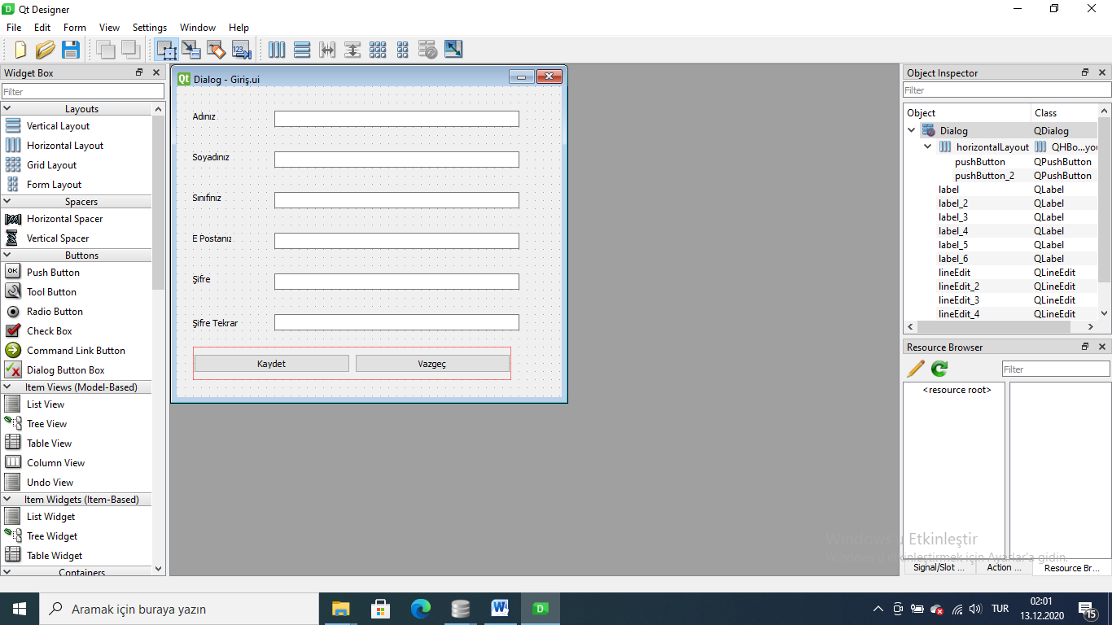

# -*- coding: utf-8 -*-

################################################################################

## Form generated from reading UI file 'Giri�XFdFtP.ui'

##

## Created by: Qt User Interface Compiler version 5.14.1

##

## WARNING! All changes made in this file will be lost when recompiling UI file!

################################################################################

from PySide2.QtCore import (QCoreApplication, QMetaObject, QObject, QPoint,

QRect, QSize, QUrl, Qt)

from PySide2.QtGui import (QBrush, QColor, QConicalGradient, QCursor, QFont,

QFontDatabase, QIcon, QLinearGradient, QPalette, QPainter, QPixmap,

QRadialGradient)

from PySide2.QtWidgets import *

class Ui_Dialog(object):

def setupUi(self, Dialog):

if Dialog.objectName():

Dialog.setObjectName(u"Dialog")

Dialog.setEnabled(True)

Dialog.resize(473, 382)

self.lineEdit = QLineEdit(Dialog)

self.lineEdit.setObjectName(u"lineEdit")

self.lineEdit.setGeometry(QRect(120, 30, 301, 20))

self.label = QLabel(Dialog)

self.label.setObjectName(u"label")

self.label.setGeometry(QRect(20, 30, 47, 13))

self.label_2 = QLabel(Dialog)

self.label_2.setObjectName(u"label_2")

self.label_2.setGeometry(QRect(20, 80, 47, 13))

self.label_3 = QLabel(Dialog)

self.label_3.setObjectName(u"label_3")

self.label_3.setGeometry(QRect(20, 130, 47, 13))

self.label_4 = QLabel(Dialog)

self.label_4.setObjectName(u"label_4")

self.label_4.setGeometry(QRect(20, 180, 47, 13))

self.lineEdit_2 = QLineEdit(Dialog)

self.lineEdit_2.setObjectName(u"lineEdit_2")

self.lineEdit_2.setGeometry(QRect(120, 80, 301, 20))

self.lineEdit_3 = QLineEdit(Dialog)

self.lineEdit_3.setObjectName(u"lineEdit_3")

self.lineEdit_3.setGeometry(QRect(120, 130, 301, 20))

self.lineEdit_4 = QLineEdit(Dialog)

self.lineEdit_4.setObjectName(u"lineEdit_4")

self.lineEdit_4.setGeometry(QRect(120, 180, 301, 20))

self.horizontalLayoutWidget = QWidget(Dialog)

self.horizontalLayoutWidget.setObjectName(u"horizontalLayoutWidget")

self.horizontalLayoutWidget.setGeometry(QRect(20, 320, 391, 41))

self.horizontalLayout = QHBoxLayout(self.horizontalLayoutWidget)

self.horizontalLayout.setObjectName(u"horizontalLayout")

self.horizontalLayout.setContentsMargins(0, 0, 0, 0)

self.pushButton_2 = QPushButton(self.horizontalLayoutWidget)

self.pushButton_2.setObjectName(u"pushButton_2")

self.horizontalLayout.addWidget(self.pushButton_2)

self.pushButton = QPushButton(self.horizontalLayoutWidget)

self.pushButton.setObjectName(u"pushButton")

self.horizontalLayout.addWidget(self.pushButton)

self.lineEdit_5 = QLineEdit(Dialog)

self.lineEdit_5.setObjectName(u"lineEdit_5")

self.lineEdit_5.setGeometry(QRect(120, 230, 301, 20))

self.label_5 = QLabel(Dialog)

self.label_5.setObjectName(u"label_5")

self.label_5.setGeometry(QRect(20, 230, 47, 13))

self.label_6 = QLabel(Dialog)

self.label_6.setObjectName(u"label_6")

self.label_6.setGeometry(QRect(20, 280, 71, 20))

self.lineEdit_6 = QLineEdit(Dialog)

self.lineEdit_6.setObjectName(u"lineEdit_6")

self.lineEdit_6.setGeometry(QRect(120, 280, 301, 20))

self.retranslateUi(Dialog)

QMetaObject.connectSlotsByName(Dialog)

# setupUi

def retranslateUi(self, Dialog):

Dialog.setWindowTitle(QCoreApplication.translate("Dialog", u"Dialog", None))

self.label.setText(QCoreApplication.translate("Dialog", u"Ad\u0131n\u0131z", None))

self.label_2.setText(QCoreApplication.translate("Dialog", u"Soyad\u0131n\u0131z", None))

self.label_3.setText(QCoreApplication.translate("Dialog", u"S\u0131n\u0131f\u0131n\u0131z", None))

self.label_4.setText(QCoreApplication.translate("Dialog", u"E Postan\u0131z", None))

self.pushButton_2.setText(QCoreApplication.translate("Dialog", u"Kaydet", None))

self.pushButton.setText(QCoreApplication.translate("Dialog", u"Vazge\u00e7", None))

self.label_5.setText(QCoreApplication.translate("Dialog", u"\u015eifre", None))

self.label_6.setText(QCoreApplication.translate("Dialog", u"\u015eifre Tekrar", None))

# retranslateUi

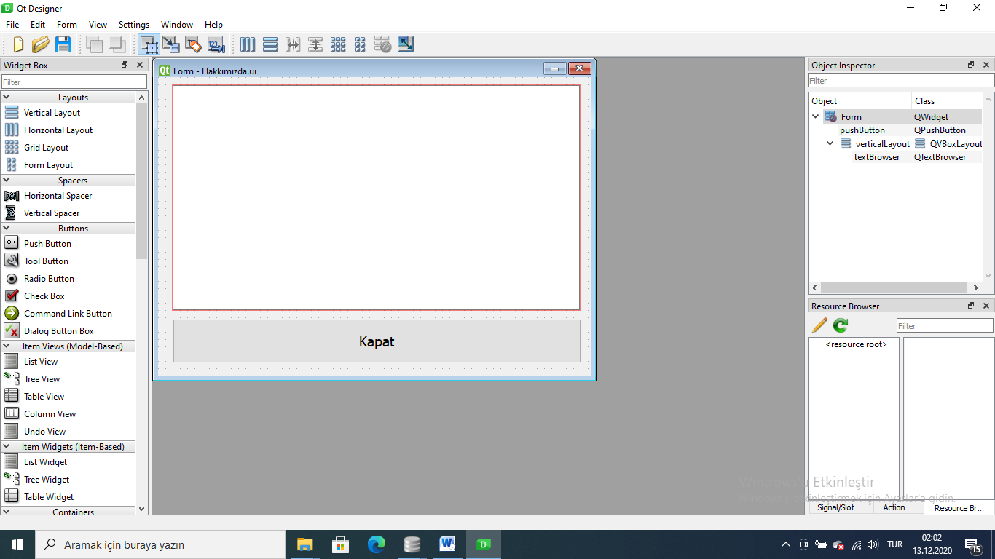

# -*- coding: utf-8 -*-

################################################################################

## Form generated from reading UI file 'Hakk�m�zdaPFvyiR.ui'

##

## Created by: Qt User Interface Compiler version 5.14.1

##

## WARNING! All changes made in this file will be lost when recompiling UI file!

################################################################################

from PySide2.QtCore import (QCoreApplication, QMetaObject, QObject, QPoint,

QRect, QSize, QUrl, Qt)

from PySide2.QtGui import (QBrush, QColor, QConicalGradient, QCursor, QFont,

QFontDatabase, QIcon, QLinearGradient, QPalette, QPainter, QPixmap,

QRadialGradient)

from PySide2.QtWidgets import *

class Ui_Form(object):

def setupUi(self, Form):

if Form.objectName():

Form.setObjectName(u"Form")

Form.resize(594, 410)

self.verticalLayoutWidget = QWidget(Form)

self.verticalLayoutWidget.setObjectName(u"verticalLayoutWidget")

self.verticalLayoutWidget.setGeometry(QRect(19, 10, 561, 311))

self.verticalLayout = QVBoxLayout(self.verticalLayoutWidget)

self.verticalLayout.setObjectName(u"verticalLayout")

self.verticalLayout.setContentsMargins(0, 0, 0, 0)

self.textBrowser = QTextBrowser(self.verticalLayoutWidget)

self.textBrowser.setObjectName(u"textBrowser")

self.verticalLayout.addWidget(self.textBrowser)

self.pushButton = QPushButton(Form)

self.pushButton.setObjectName(u"pushButton")

self.pushButton.setGeometry(QRect(20, 332, 561, 61))

font = QFont()

font.setPointSize(14)

self.pushButton.setFont(font)

self.retranslateUi(Form)

QMetaObject.connectSlotsByName(Form)

# setupUi

def retranslateUi(self, Form):

Form.setWindowTitle(QCoreApplication.translate("Form", u"Form", None))

self.pushButton.setText(QCoreApplication.translate("Form", u"Kapat", None))

# retranslateUi

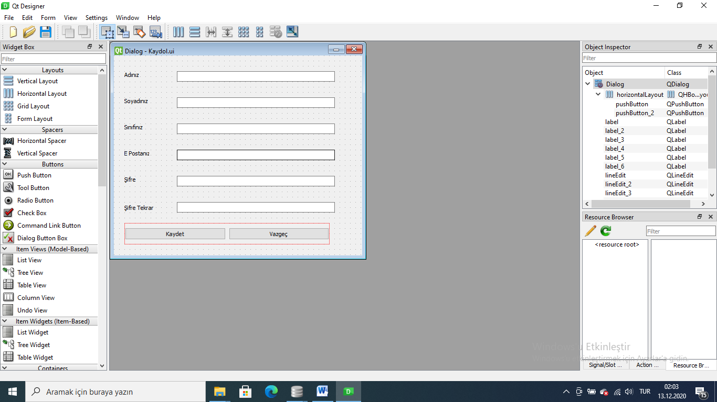

# -*- coding: utf-8 -*-

################################################################################

## Form generated from reading UI file 'KaydolKtclAK.ui'

##

## Created by: Qt User Interface Compiler version 5.14.1

##

## WARNING! All changes made in this file will be lost when recompiling UI file!

################################################################################

from PySide2.QtCore import (QCoreApplication, QMetaObject, QObject, QPoint,

QRect, QSize, QUrl, Qt)

from PySide2.QtGui import (QBrush, QColor, QConicalGradient, QCursor, QFont,

QFontDatabase, QIcon, QLinearGradient, QPalette, QPainter, QPixmap,

QRadialGradient)

from PySide2.QtWidgets import *

class Ui_Dialog(object):

def setupUi(self, Dialog):

if Dialog.objectName():

Dialog.setObjectName(u"Dialog")

Dialog.setEnabled(True)

Dialog.resize(473, 382)

self.lineEdit = QLineEdit(Dialog)

self.lineEdit.setObjectName(u"lineEdit")

self.lineEdit.setGeometry(QRect(120, 30, 301, 20))

self.label = QLabel(Dialog)

self.label.setObjectName(u"label")

self.label.setGeometry(QRect(20, 30, 47, 13))

self.label_2 = QLabel(Dialog)

self.label_2.setObjectName(u"label_2")

self.label_2.setGeometry(QRect(20, 80, 47, 13))

self.label_3 = QLabel(Dialog)

self.label_3.setObjectName(u"label_3")

self.label_3.setGeometry(QRect(20, 130, 47, 13))

self.label_4 = QLabel(Dialog)

self.label_4.setObjectName(u"label_4")

self.label_4.setGeometry(QRect(20, 180, 47, 13))

self.lineEdit_2 = QLineEdit(Dialog)

self.lineEdit_2.setObjectName(u"lineEdit_2")

self.lineEdit_2.setGeometry(QRect(120, 80, 301, 20))

self.lineEdit_3 = QLineEdit(Dialog)

self.lineEdit_3.setObjectName(u"lineEdit_3")

self.lineEdit_3.setGeometry(QRect(120, 130, 301, 20))

self.lineEdit_4 = QLineEdit(Dialog)

self.lineEdit_4.setObjectName(u"lineEdit_4")

self.lineEdit_4.setGeometry(QRect(120, 180, 301, 20))

self.horizontalLayoutWidget = QWidget(Dialog)

self.horizontalLayoutWidget.setObjectName(u"horizontalLayoutWidget")

self.horizontalLayoutWidget.setGeometry(QRect(20, 320, 391, 41))

self.horizontalLayout = QHBoxLayout(self.horizontalLayoutWidget)

self.horizontalLayout.setObjectName(u"horizontalLayout")

self.horizontalLayout.setContentsMargins(0, 0, 0, 0)

self.pushButton_2 = QPushButton(self.horizontalLayoutWidget)

self.pushButton_2.setObjectName(u"pushButton_2")

self.horizontalLayout.addWidget(self.pushButton_2)

self.pushButton = QPushButton(self.horizontalLayoutWidget)

self.pushButton.setObjectName(u"pushButton")

self.horizontalLayout.addWidget(self.pushButton)

self.lineEdit_5 = QLineEdit(Dialog)

self.lineEdit_5.setObjectName(u"lineEdit_5")

self.lineEdit_5.setGeometry(QRect(120, 230, 301, 20))

self.label_5 = QLabel(Dialog)

self.label_5.setObjectName(u"label_5")

self.label_5.setGeometry(QRect(20, 230, 47, 13))

self.label_6 = QLabel(Dialog)

self.label_6.setObjectName(u"label_6")

self.label_6.setGeometry(QRect(20, 280, 71, 20))

self.lineEdit_6 = QLineEdit(Dialog)

self.lineEdit_6.setObjectName(u"lineEdit_6")

self.lineEdit_6.setGeometry(QRect(120, 280, 301, 20))

self.retranslateUi(Dialog)

QMetaObject.connectSlotsByName(Dialog)

# setupUi

def retranslateUi(self, Dialog):

Dialog.setWindowTitle(QCoreApplication.translate("Dialog", u"Dialog", None))

self.label.setText(QCoreApplication.translate("Dialog", u"Ad\u0131n\u0131z", None))

self.label_2.setText(QCoreApplication.translate("Dialog", u"Soyad\u0131n\u0131z", None))

self.label_3.setText(QCoreApplication.translate("Dialog", u"S\u0131n\u0131f\u0131n\u0131z", None))

self.label_4.setText(QCoreApplication.translate("Dialog", u"E Postan\u0131z", None))

self.pushButton_2.setText(QCoreApplication.translate("Dialog", u"Kaydet", None))

self.pushButton.setText(QCoreApplication.translate("Dialog", u"Vazge\u00e7", None))

self.label_5.setText(QCoreApplication.translate("Dialog", u"\u015eifre", None))

self.label_6.setText(QCoreApplication.translate("Dialog", u"\u015eifre Tekrar", None))

# retranslateUi

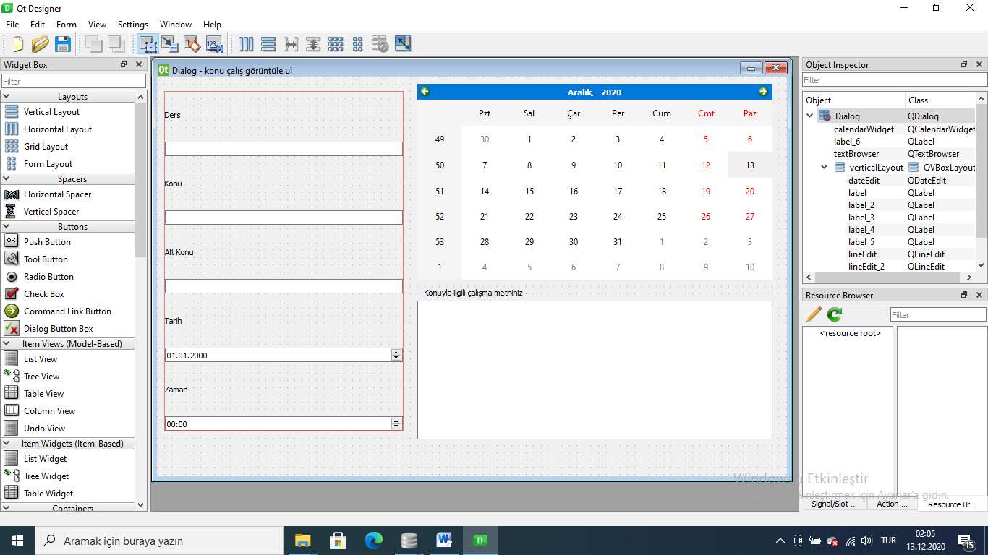

# -*- coding: utf-8 -*-

################################################################################

## Form generated from reading UI file 'konu �al�� g�r�nt�leIbTYyW.ui'

##

## Created by: Qt User Interface Compiler version 5.14.1

##

## WARNING! All changes made in this file will be lost when recompiling UI file!

################################################################################

from PySide2.QtCore import (QCoreApplication, QMetaObject, QObject, QPoint,

QRect, QSize, QUrl, Qt)

from PySide2.QtGui import (QBrush, QColor, QConicalGradient, QCursor, QFont,

QFontDatabase, QIcon, QLinearGradient, QPalette, QPainter, QPixmap,

QRadialGradient)

from PySide2.QtWidgets import *

class Ui_Dialog(object):

def setupUi(self, Dialog):

if Dialog.objectName():

Dialog.setObjectName(u"Dialog")

Dialog.resize(871, 553)

self.verticalLayoutWidget = QWidget(Dialog)

self.verticalLayoutWidget.setObjectName(u"verticalLayoutWidget")

self.verticalLayoutWidget.setGeometry(QRect(10, 20, 331, 471))

self.verticalLayout = QVBoxLayout(self.verticalLayoutWidget)

self.verticalLayout.setObjectName(u"verticalLayout")

self.verticalLayout.setContentsMargins(0, 0, 0, 0)

self.label_3 = QLabel(self.verticalLayoutWidget)

self.label_3.setObjectName(u"label_3")

self.verticalLayout.addWidget(self.label_3)

self.lineEdit = QLineEdit(self.verticalLayoutWidget)

self.lineEdit.setObjectName(u"lineEdit")

self.verticalLayout.addWidget(self.lineEdit)

self.label_2 = QLabel(self.verticalLayoutWidget)

self.label_2.setObjectName(u"label_2")

self.verticalLayout.addWidget(self.label_2)

self.lineEdit_2 = QLineEdit(self.verticalLayoutWidget)

self.lineEdit_2.setObjectName(u"lineEdit_2")

self.verticalLayout.addWidget(self.lineEdit_2)

self.label_4 = QLabel(self.verticalLayoutWidget)

self.label_4.setObjectName(u"label_4")

self.verticalLayout.addWidget(self.label_4)

self.lineEdit_3 = QLineEdit(self.verticalLayoutWidget)

self.lineEdit_3.setObjectName(u"lineEdit_3")

self.verticalLayout.addWidget(self.lineEdit_3)

self.label_5 = QLabel(self.verticalLayoutWidget)

self.label_5.setObjectName(u"label_5")

self.verticalLayout.addWidget(self.label_5)

self.dateEdit = QDateEdit(self.verticalLayoutWidget)

self.dateEdit.setObjectName(u"dateEdit")

self.verticalLayout.addWidget(self.dateEdit)

self.label = QLabel(self.verticalLayoutWidget)

self.label.setObjectName(u"label")

self.verticalLayout.addWidget(self.label)

self.timeEdit = QTimeEdit(self.verticalLayoutWidget)

self.timeEdit.setObjectName(u"timeEdit")

self.verticalLayout.addWidget(self.timeEdit)

self.calendarWidget = QCalendarWidget(Dialog)

self.calendarWidget.setObjectName(u"calendarWidget")

self.calendarWidget.setGeometry(QRect(360, 10, 491, 271))

self.label_6 = QLabel(Dialog)

self.label_6.setObjectName(u"label_6")

self.label_6.setGeometry(QRect(370, 290, 331, 16))

self.textBrowser = QTextBrowser(Dialog)

self.textBrowser.setObjectName(u"textBrowser")

self.textBrowser.setGeometry(QRect(360, 310, 491, 192))

self.retranslateUi(Dialog)

QMetaObject.connectSlotsByName(Dialog)

# setupUi

def retranslateUi(self, Dialog):

Dialog.setWindowTitle(QCoreApplication.translate("Dialog", u"Dialog", None))

self.label_3.setText(QCoreApplication.translate("Dialog", u"Ders", None))

self.label_2.setText(QCoreApplication.translate("Dialog", u"Konu", None))

self.label_4.setText(QCoreApplication.translate("Dialog", u"Alt Konu", None))

self.label_5.setText(QCoreApplication.translate("Dialog", u"Tarih", None))

self.label.setText(QCoreApplication.translate("Dialog", u"Zaman", None))

self.label_6.setText(QCoreApplication.translate("Dialog", u"Konuyla ilgili \u00e7al\u0131\u015fma metniniz", None))

# retranslateUi

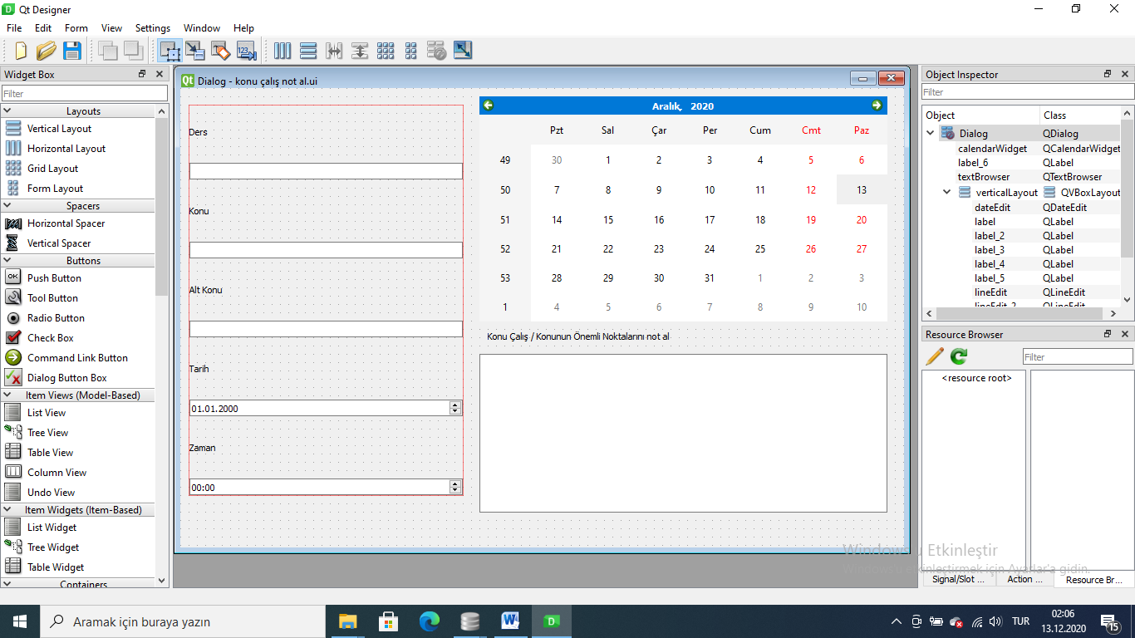

# -*- coding: utf-8 -*-

################################################################################

## Form generated from reading UI file 'konu �al�� not alUSHwoU.ui'

##

## Created by: Qt User Interface Compiler version 5.14.1

##

## WARNING! All changes made in this file will be lost when recompiling UI file!

################################################################################

from PySide2.QtCore import (QCoreApplication, QMetaObject, QObject, QPoint,

QRect, QSize, QUrl, Qt)

from PySide2.QtGui import (QBrush, QColor, QConicalGradient, QCursor, QFont,

QFontDatabase, QIcon, QLinearGradient, QPalette, QPainter, QPixmap,

QRadialGradient)

from PySide2.QtWidgets import *

class Ui_Dialog(object):

def setupUi(self, Dialog):

if Dialog.objectName():

Dialog.setObjectName(u"Dialog")

Dialog.resize(871, 553)

self.verticalLayoutWidget = QWidget(Dialog)

self.verticalLayoutWidget.setObjectName(u"verticalLayoutWidget")

self.verticalLayoutWidget.setGeometry(QRect(10, 20, 331, 471))

self.verticalLayout = QVBoxLayout(self.verticalLayoutWidget)

self.verticalLayout.setObjectName(u"verticalLayout")

self.verticalLayout.setContentsMargins(0, 0, 0, 0)

self.label_3 = QLabel(self.verticalLayoutWidget)

self.label_3.setObjectName(u"label_3")

self.verticalLayout.addWidget(self.label_3)

self.lineEdit = QLineEdit(self.verticalLayoutWidget)

self.lineEdit.setObjectName(u"lineEdit")

self.verticalLayout.addWidget(self.lineEdit)

self.label_2 = QLabel(self.verticalLayoutWidget)

self.label_2.setObjectName(u"label_2")

self.verticalLayout.addWidget(self.label_2)

self.lineEdit_2 = QLineEdit(self.verticalLayoutWidget)

self.lineEdit_2.setObjectName(u"lineEdit_2")

self.verticalLayout.addWidget(self.lineEdit_2)

self.label_4 = QLabel(self.verticalLayoutWidget)

self.label_4.setObjectName(u"label_4")

self.verticalLayout.addWidget(self.label_4)

self.lineEdit_3 = QLineEdit(self.verticalLayoutWidget)

self.lineEdit_3.setObjectName(u"lineEdit_3")

self.verticalLayout.addWidget(self.lineEdit_3)

self.label_5 = QLabel(self.verticalLayoutWidget)

self.label_5.setObjectName(u"label_5")

self.verticalLayout.addWidget(self.label_5)

self.dateEdit = QDateEdit(self.verticalLayoutWidget)

self.dateEdit.setObjectName(u"dateEdit")

self.verticalLayout.addWidget(self.dateEdit)

self.label = QLabel(self.verticalLayoutWidget)

self.label.setObjectName(u"label")

self.verticalLayout.addWidget(self.label)

self.timeEdit = QTimeEdit(self.verticalLayoutWidget)

self.timeEdit.setObjectName(u"timeEdit")

self.verticalLayout.addWidget(self.timeEdit)

self.calendarWidget = QCalendarWidget(Dialog)

self.calendarWidget.setObjectName(u"calendarWidget")

self.calendarWidget.setGeometry(QRect(360, 10, 491, 271))

self.textBrowser = QTextBrowser(Dialog)

self.textBrowser.setObjectName(u"textBrowser")

self.textBrowser.setGeometry(QRect(360, 320, 491, 191))

self.label_6 = QLabel(Dialog)

self.label_6.setObjectName(u"label_6")

self.label_6.setGeometry(QRect(370, 290, 331, 16))

self.retranslateUi(Dialog)

QMetaObject.connectSlotsByName(Dialog)

# setupUi

def retranslateUi(self, Dialog):

Dialog.setWindowTitle(QCoreApplication.translate("Dialog", u"Dialog", None))

self.label_3.setText(QCoreApplication.translate("Dialog", u"Ders", None))

self.label_2.setText(QCoreApplication.translate("Dialog", u"Konu", None))

self.label_4.setText(QCoreApplication.translate("Dialog", u"Alt Konu", None))

self.label_5.setText(QCoreApplication.translate("Dialog", u"Tarih", None))

self.label.setText(QCoreApplication.translate("Dialog", u"Zaman", None))

self.label_6.setText(QCoreApplication.translate("Dialog", u"Konu \u00c7al\u0131\u015f / Konunun \u00d6nemli Noktalar\u0131n\u0131 not al", None))

# retranslateUi

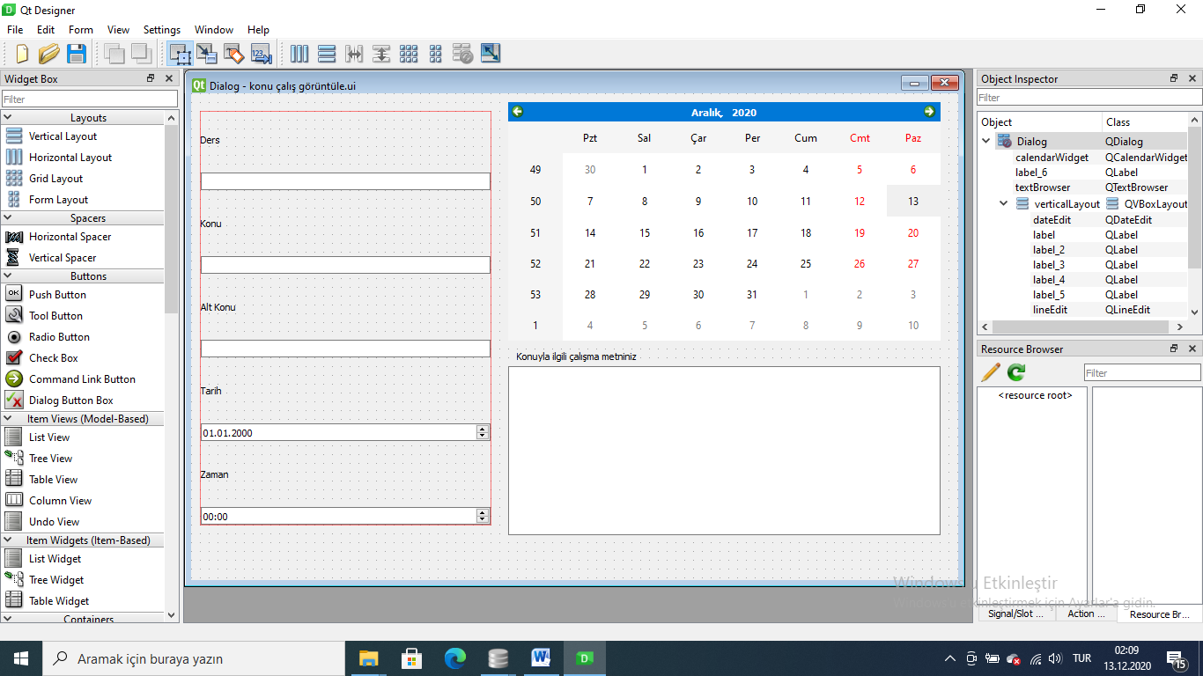

# -*- coding: utf-8 -*-

################################################################################

## Form generated from reading UI file 'konu �al�� g�r�nt�leZvvaFy.ui'

##

## Created by: Qt User Interface Compiler version 5.14.1

##

## WARNING! All changes made in this file will be lost when recompiling UI file!

################################################################################

from PySide2.QtCore import (QCoreApplication, QMetaObject, QObject, QPoint,

QRect, QSize, QUrl, Qt)

from PySide2.QtGui import (QBrush, QColor, QConicalGradient, QCursor, QFont,

QFontDatabase, QIcon, QLinearGradient, QPalette, QPainter, QPixmap,

QRadialGradient)

from PySide2.QtWidgets import *

class Ui_Dialog(object):

def setupUi(self, Dialog):

if Dialog.objectName():

Dialog.setObjectName(u"Dialog")

Dialog.resize(871, 553)

self.verticalLayoutWidget = QWidget(Dialog)

self.verticalLayoutWidget.setObjectName(u"verticalLayoutWidget")

self.verticalLayoutWidget.setGeometry(QRect(10, 20, 331, 471))

self.verticalLayout = QVBoxLayout(self.verticalLayoutWidget)

self.verticalLayout.setObjectName(u"verticalLayout")

self.verticalLayout.setContentsMargins(0, 0, 0, 0)

self.label_3 = QLabel(self.verticalLayoutWidget)

self.label_3.setObjectName(u"label_3")

self.verticalLayout.addWidget(self.label_3)

self.lineEdit = QLineEdit(self.verticalLayoutWidget)

self.lineEdit.setObjectName(u"lineEdit")

self.verticalLayout.addWidget(self.lineEdit)

self.label_2 = QLabel(self.verticalLayoutWidget)

self.label_2.setObjectName(u"label_2")

self.verticalLayout.addWidget(self.label_2)

self.lineEdit_2 = QLineEdit(self.verticalLayoutWidget)

self.lineEdit_2.setObjectName(u"lineEdit_2")

self.verticalLayout.addWidget(self.lineEdit_2)

self.label_4 = QLabel(self.verticalLayoutWidget)

self.label_4.setObjectName(u"label_4")

self.verticalLayout.addWidget(self.label_4)

self.lineEdit_3 = QLineEdit(self.verticalLayoutWidget)

self.lineEdit_3.setObjectName(u"lineEdit_3")

self.verticalLayout.addWidget(self.lineEdit_3)

self.label_5 = QLabel(self.verticalLayoutWidget)

self.label_5.setObjectName(u"label_5")

self.verticalLayout.addWidget(self.label_5)

self.dateEdit = QDateEdit(self.verticalLayoutWidget)

self.dateEdit.setObjectName(u"dateEdit")

self.verticalLayout.addWidget(self.dateEdit)

self.label = QLabel(self.verticalLayoutWidget)

self.label.setObjectName(u"label")

self.verticalLayout.addWidget(self.label)

self.timeEdit = QTimeEdit(self.verticalLayoutWidget)

self.timeEdit.setObjectName(u"timeEdit")

self.verticalLayout.addWidget(self.timeEdit)

self.calendarWidget = QCalendarWidget(Dialog)

self.calendarWidget.setObjectName(u"calendarWidget")

self.calendarWidget.setGeometry(QRect(360, 10, 491, 271))

self.label_6 = QLabel(Dialog)

self.label_6.setObjectName(u"label_6")

self.label_6.setGeometry(QRect(370, 290, 331, 16))

self.textBrowser = QTextBrowser(Dialog)

self.textBrowser.setObjectName(u"textBrowser")

self.textBrowser.setGeometry(QRect(360, 310, 491, 192))

self.retranslateUi(Dialog)

QMetaObject.connectSlotsByName(Dialog)

# setupUi

def retranslateUi(self, Dialog):

Dialog.setWindowTitle(QCoreApplication.translate("Dialog", u"Dialog", None))

self.label_3.setText(QCoreApplication.translate("Dialog", u"Ders", None))

self.label_2.setText(QCoreApplication.translate("Dialog", u"Konu", None))

self.label_4.setText(QCoreApplication.translate("Dialog", u"Alt Konu", None))

self.label_5.setText(QCoreApplication.translate("Dialog", u"Tarih", None))

self.label.setText(QCoreApplication.translate("Dialog", u"Zaman", None))

self.label_6.setText(QCoreApplication.translate("Dialog", u"Konuyla ilgili \u00e7al\u0131\u015fma metniniz", None))

# retranslateUi

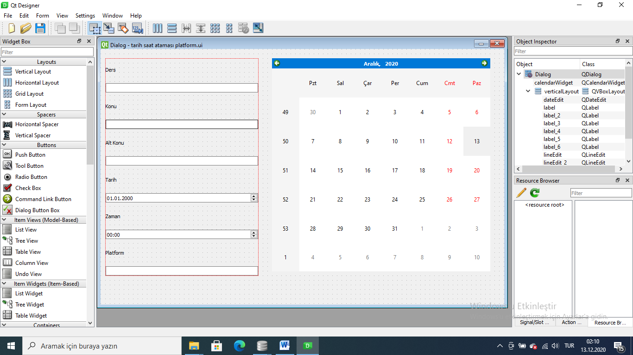

# -*- coding: utf-8 -*-

################################################################################

## Form generated from reading UI file 'tarih saat atamas� platformlqVQLh.ui'

##

## Created by: Qt User Interface Compiler version 5.14.1

##

## WARNING! All changes made in this file will be lost when recompiling UI file!

################################################################################

from PySide2.QtCore import (QCoreApplication, QMetaObject, QObject, QPoint,

QRect, QSize, QUrl, Qt)

from PySide2.QtGui import (QBrush, QColor, QConicalGradient, QCursor, QFont,

QFontDatabase, QIcon, QLinearGradient, QPalette, QPainter, QPixmap,

QRadialGradient)

from PySide2.QtWidgets import *

class Ui_Dialog(object):

def setupUi(self, Dialog):

if Dialog.objectName():

Dialog.setObjectName(u"Dialog")

Dialog.resize(871, 553)

self.verticalLayoutWidget = QWidget(Dialog)

self.verticalLayoutWidget.setObjectName(u"verticalLayoutWidget")

self.verticalLayoutWidget.setGeometry(QRect(10, 20, 331, 471))

self.verticalLayout = QVBoxLayout(self.verticalLayoutWidget)

self.verticalLayout.setObjectName(u"verticalLayout")

self.verticalLayout.setContentsMargins(0, 0, 0, 0)

self.label_3 = QLabel(self.verticalLayoutWidget)

self.label_3.setObjectName(u"label_3")

self.verticalLayout.addWidget(self.label_3)

self.lineEdit = QLineEdit(self.verticalLayoutWidget)

self.lineEdit.setObjectName(u"lineEdit")

self.verticalLayout.addWidget(self.lineEdit)

self.label_2 = QLabel(self.verticalLayoutWidget)

self.label_2.setObjectName(u"label_2")

self.verticalLayout.addWidget(self.label_2)

self.lineEdit_2 = QLineEdit(self.verticalLayoutWidget)

self.lineEdit_2.setObjectName(u"lineEdit_2")

self.verticalLayout.addWidget(self.lineEdit_2)

self.label_4 = QLabel(self.verticalLayoutWidget)

self.label_4.setObjectName(u"label_4")

self.verticalLayout.addWidget(self.label_4)

self.lineEdit_3 = QLineEdit(self.verticalLayoutWidget)

self.lineEdit_3.setObjectName(u"lineEdit_3")

self.verticalLayout.addWidget(self.lineEdit_3)

self.label_5 = QLabel(self.verticalLayoutWidget)

self.label_5.setObjectName(u"label_5")

self.verticalLayout.addWidget(self.label_5)

self.dateEdit = QDateEdit(self.verticalLayoutWidget)

self.dateEdit.setObjectName(u"dateEdit")

self.verticalLayout.addWidget(self.dateEdit)

self.label = QLabel(self.verticalLayoutWidget)

self.label.setObjectName(u"label")

self.verticalLayout.addWidget(self.label)

self.timeEdit = QTimeEdit(self.verticalLayoutWidget)

self.timeEdit.setObjectName(u"timeEdit")

self.verticalLayout.addWidget(self.timeEdit)

self.label_6 = QLabel(self.verticalLayoutWidget)

self.label_6.setObjectName(u"label_6")

self.verticalLayout.addWidget(self.label_6)

self.lineEdit_4 = QLineEdit(self.verticalLayoutWidget)

self.lineEdit_4.setObjectName(u"lineEdit_4")

self.verticalLayout.addWidget(self.lineEdit_4)

self.calendarWidget = QCalendarWidget(Dialog)

self.calendarWidget.setObjectName(u"calendarWidget")

self.calendarWidget.setGeometry(QRect(370, 20, 471, 461))

self.retranslateUi(Dialog)

QMetaObject.connectSlotsByName(Dialog)

# setupUi

def retranslateUi(self, Dialog):

Dialog.setWindowTitle(QCoreApplication.translate("Dialog", u"Dialog", None))

self.label_3.setText(QCoreApplication.translate("Dialog", u"Ders", None))

self.label_2.setText(QCoreApplication.translate("Dialog", u"Konu", None))

self.label_4.setText(QCoreApplication.translate("Dialog", u"Alt Konu", None))

self.label_5.setText(QCoreApplication.translate("Dialog", u"Tarih", None))

self.label.setText(QCoreApplication.translate("Dialog", u"Zaman", None))

self.label_6.setText(QCoreApplication.translate("Dialog", u"Platform", None))

# retranslateUi

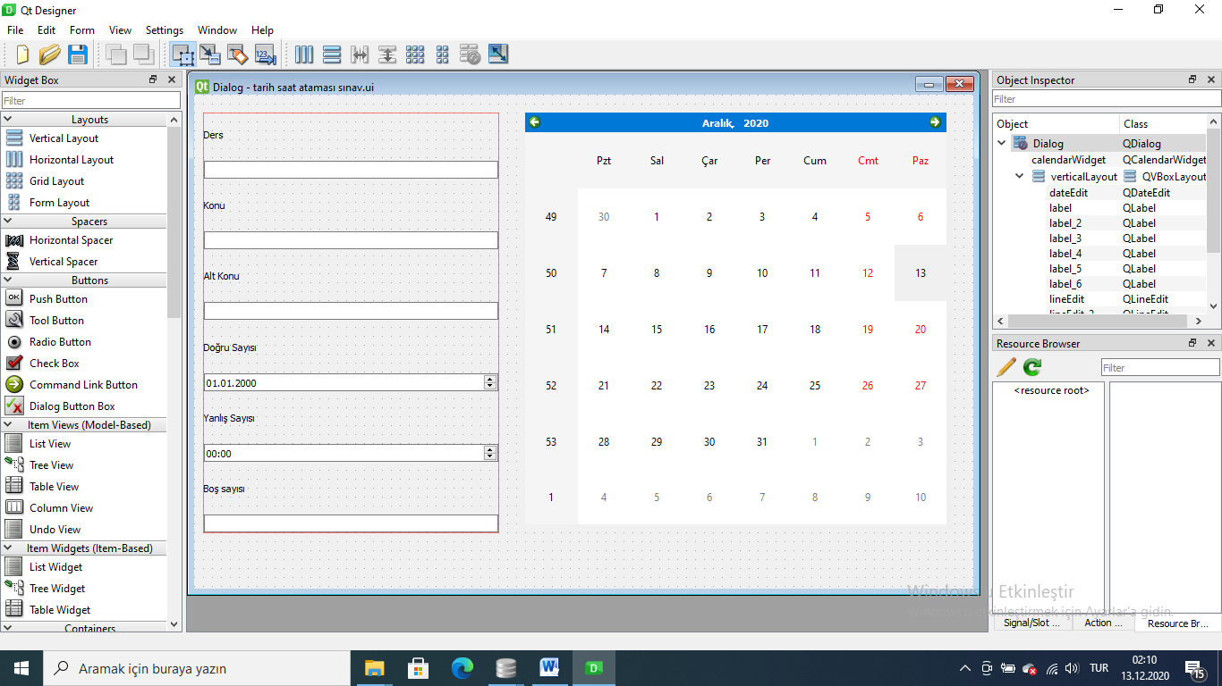

# -*- coding: utf-8 -*-

################################################################################

## Form generated from reading UI file 'tarih saat atamas� s�navGNNpzY.ui'

##

## Created by: Qt User Interface Compiler version 5.14.1

##

## WARNING! All changes made in this file will be lost when recompiling UI file!

################################################################################

from PySide2.QtCore import (QCoreApplication, QMetaObject, QObject, QPoint,

QRect, QSize, QUrl, Qt)

from PySide2.QtGui import (QBrush, QColor, QConicalGradient, QCursor, QFont,

QFontDatabase, QIcon, QLinearGradient, QPalette, QPainter, QPixmap,

QRadialGradient)

from PySide2.QtWidgets import *

class Ui_Dialog(object):

def setupUi(self, Dialog):

if Dialog.objectName():

Dialog.setObjectName(u"Dialog")

Dialog.resize(871, 553)

self.verticalLayoutWidget = QWidget(Dialog)

self.verticalLayoutWidget.setObjectName(u"verticalLayoutWidget")

self.verticalLayoutWidget.setGeometry(QRect(10, 20, 331, 471))

self.verticalLayout = QVBoxLayout(self.verticalLayoutWidget)

self.verticalLayout.setObjectName(u"verticalLayout")

self.verticalLayout.setContentsMargins(0, 0, 0, 0)

self.label_3 = QLabel(self.verticalLayoutWidget)

self.label_3.setObjectName(u"label_3")

self.verticalLayout.addWidget(self.label_3)

self.lineEdit = QLineEdit(self.verticalLayoutWidget)

self.lineEdit.setObjectName(u"lineEdit")

self.verticalLayout.addWidget(self.lineEdit)

self.label_2 = QLabel(self.verticalLayoutWidget)

self.label_2.setObjectName(u"label_2")

self.verticalLayout.addWidget(self.label_2)

self.lineEdit_2 = QLineEdit(self.verticalLayoutWidget)

self.lineEdit_2.setObjectName(u"lineEdit_2")

self.verticalLayout.addWidget(self.lineEdit_2)

self.label_4 = QLabel(self.verticalLayoutWidget)

self.label_4.setObjectName(u"label_4")

self.verticalLayout.addWidget(self.label_4)

self.lineEdit_3 = QLineEdit(self.verticalLayoutWidget)

self.lineEdit_3.setObjectName(u"lineEdit_3")

self.verticalLayout.addWidget(self.lineEdit_3)

self.label_5 = QLabel(self.verticalLayoutWidget)

self.label_5.setObjectName(u"label_5")

self.verticalLayout.addWidget(self.label_5)

self.dateEdit = QDateEdit(self.verticalLayoutWidget)

self.dateEdit.setObjectName(u"dateEdit")

self.verticalLayout.addWidget(self.dateEdit)

self.label = QLabel(self.verticalLayoutWidget)

self.label.setObjectName(u"label")

self.verticalLayout.addWidget(self.label)

self.timeEdit = QTimeEdit(self.verticalLayoutWidget)

self.timeEdit.setObjectName(u"timeEdit")

self.verticalLayout.addWidget(self.timeEdit)

self.label_6 = QLabel(self.verticalLayoutWidget)

self.label_6.setObjectName(u"label_6")

self.verticalLayout.addWidget(self.label_6)

self.lineEdit_4 = QLineEdit(self.verticalLayoutWidget)

self.lineEdit_4.setObjectName(u"lineEdit_4")

self.verticalLayout.addWidget(self.lineEdit_4)

self.calendarWidget = QCalendarWidget(Dialog)

self.calendarWidget.setObjectName(u"calendarWidget")

self.calendarWidget.setGeometry(QRect(370, 20, 471, 461))

self.retranslateUi(Dialog)

QMetaObject.connectSlotsByName(Dialog)

# setupUi

def retranslateUi(self, Dialog):

Dialog.setWindowTitle(QCoreApplication.translate("Dialog", u"Dialog", None))

self.label_3.setText(QCoreApplication.translate("Dialog", u"Ders", None))

self.label_2.setText(QCoreApplication.translate("Dialog", u"Konu", None))

self.label_4.setText(QCoreApplication.translate("Dialog", u"Alt Konu", None))

self.label_5.setText(QCoreApplication.translate("Dialog", u"Do\u011fru Say\u0131s\u0131", None))

self.label.setText(QCoreApplication.translate("Dialog", u"Yanl\u0131\u015f Say\u0131s\u0131", None))

self.label_6.setText(QCoreApplication.translate("Dialog", u"Bo\u015f say\u0131s\u0131", None))

# retranslateUi

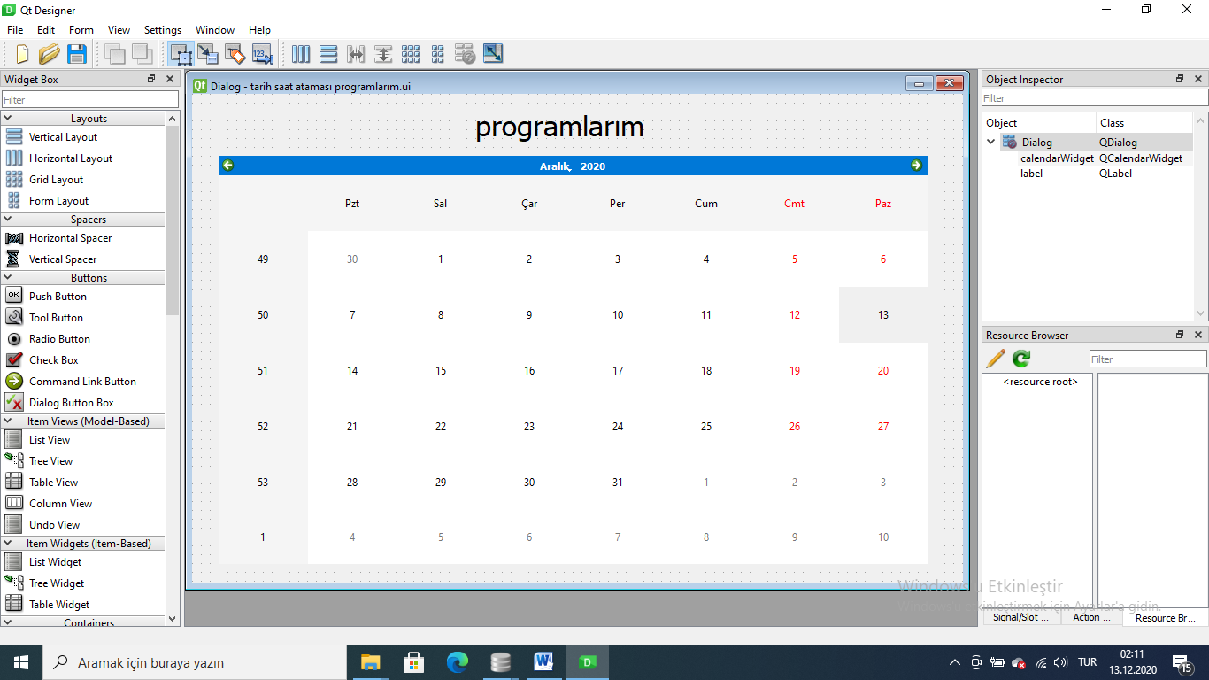

# -*- coding: utf-8 -*-

################################################################################

## Form generated from reading UI file 'tarih saat atamas� programlar�mFwLGJj.ui'

##

## Created by: Qt User Interface Compiler version 5.14.1

##

## WARNING! All changes made in this file will be lost when recompiling UI file!

################################################################################

from PySide2.QtCore import (QCoreApplication, QMetaObject, QObject, QPoint,

QRect, QSize, QUrl, Qt)

from PySide2.QtGui import (QBrush, QColor, QConicalGradient, QCursor, QFont,

QFontDatabase, QIcon, QLinearGradient, QPalette, QPainter, QPixmap,

QRadialGradient)

from PySide2.QtWidgets import *

class Ui_Dialog(object):

def setupUi(self, Dialog):

if Dialog.objectName():

Dialog.setObjectName(u"Dialog")

Dialog.resize(871, 553)

self.calendarWidget = QCalendarWidget(Dialog)

self.calendarWidget.setObjectName(u"calendarWidget")

self.calendarWidget.setGeometry(QRect(30, 70, 801, 461))

self.label = QLabel(Dialog)

self.label.setObjectName(u"label")

self.label.setGeometry(QRect(320, 10, 221, 51))

font = QFont()

font.setPointSize(24)

self.label.setFont(font)

self.retranslateUi(Dialog)

QMetaObject.connectSlotsByName(Dialog)

# setupUi

def retranslateUi(self, Dialog):

Dialog.setWindowTitle(QCoreApplication.translate("Dialog", u"Dialog", None))

self.label.setText(QCoreApplication.translate("Dialog", u"programlar\u0131m", None))

# retranslateUi